Complecated Interview question
- What is Fail safe and Fail interator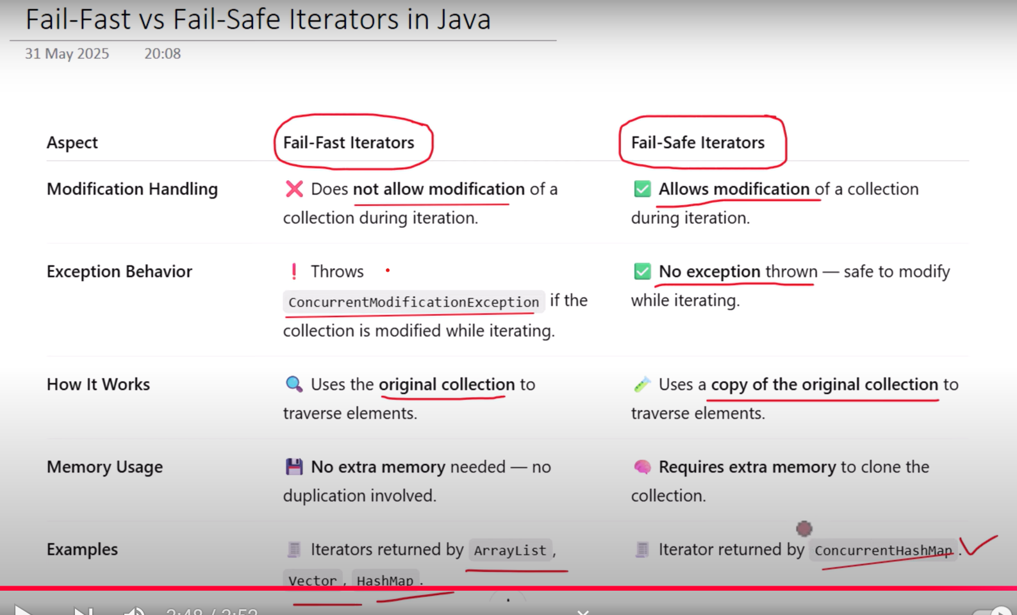

- What is Acid Properties

Atomicity
Either all or null
Either it will complete all the operation until commit or if the transaction is failed any where then we can rollback all the operation.
If we do payment if payment then we need to do the transaction/payment again
Consistancy
Before the transaction start and after the transaction completed the sum of the money should be same

A having 2000 rs and B having 3000 rs A is transferring 1000 rs to B so B is having 4000 and A is having 1000 rs so before transaction sum of money 5000 and after transaction the sum of money is 5000.
Isolation
Transactions must operate independently. One transaction should not affect another, even if executed concurrently.
- Two users try to book the last movie ticket at the same time.
- Isolation ensures:
  - Only one user gets the ticket.
  - The other user's transaction is rolled back or retried.

Durability
What are the changes we are doing in the data that is happen on permant basis.
Order Confirmation in E-Commerce
- You place an order and receive a confirmation.
- Even if the system crashes right after, your order remains saved in the database.
- Durability ensures your data is not lost after success.

